AIM ONLINE NEWSLETTER  Featured Articles  €€ • Dashboards and Scorecards  •  •The dynamics of change  •  •Human Capital: The “People” Business  Inside AIM  Home Page  Recent News  Learning with AIM  Thought Leadership  •  Tell a Friend  Know someone who might like to receive our FREE monthly newsletter on a regular basis? Use our Forward to a friend link.  My AIM  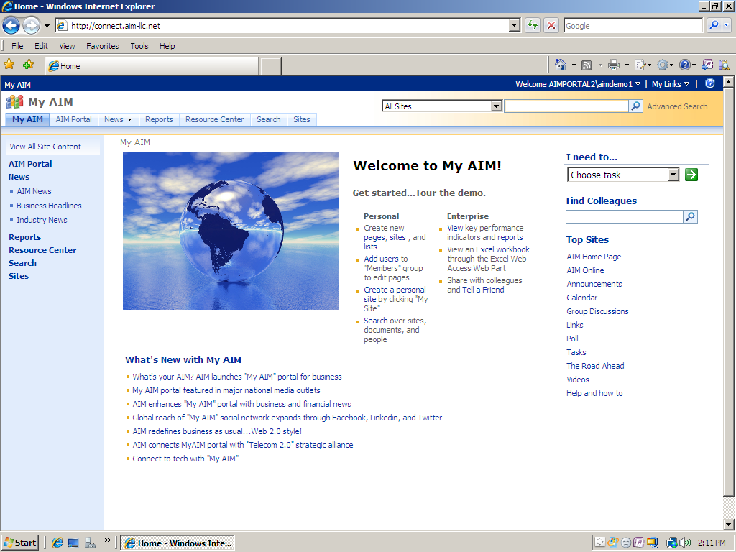  Contact Us  Have any comments or question, please Contact Us. |  | FORESIGHT© April Issue  Dashboards and Scorecards…The insight of intelligence  How does your organization understand the changing environment both inside and outside its doors? What is the process that your organization communicates an actionable strategy?  [Learn more]  News and Highlights  Join AIM Online  A valuable resource, AIM Online offers a FREE membership while providing exclusive access to industry insight thought leadership, and “deep” discounts for AIM solutions and services. Subscribe to FORESIGHT©, our free monthly newsletter. Become a member TODAY….Join AIM Online!  [Learn more]  Education and Events  JOIN AIM at our world-class educational events  Introduction to Strategy Mapping Web Conference April 20, 2010 11 a.m. (EST)  Strategy Mapping Conference Executive Conference April 27, 2010 14 Wall Street New York City, NY  [Learn more] *AIM Online Member Code - APR10  Target Success with AIM  Community · Collaborate · Connect  What’s your AIM? “My AIM” provides collaboration, and connections to knowledge, expertise, and community through business social networking. Grow with the best…AIM. Target Success. Connect  [Learn more]  Thought Leadership  Knowledge is Power  Whether it is the latest thinking on change, innovation, or strategy AIM has the expertise and resources you need. Visit the AIM Bookstore where you can find the latest articles, books, journals, and publications that affect your success.  [Learn More]  AIM LLC · 217 Country Club Park · Birmingham, AL 35213 consulting@aim-llc.net · 1.205.358.4152 · www.aim-llc.net

